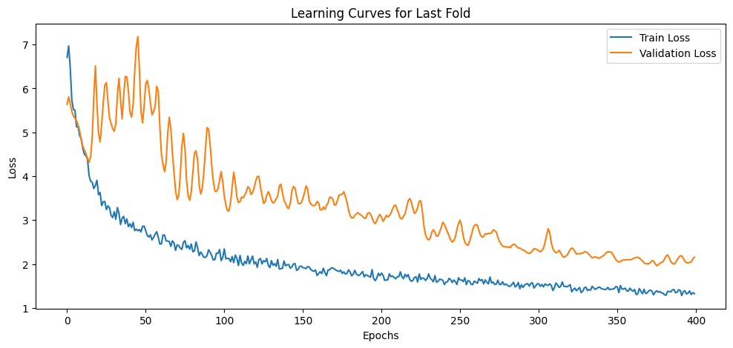(5.1 Validation )

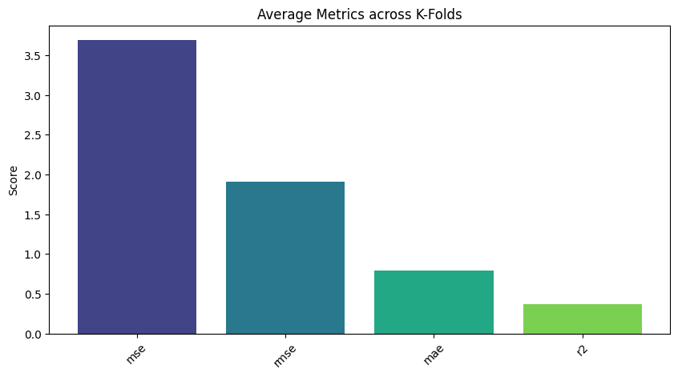(5.2 Average metrics)

**Average Metrics:**

* Average Test Mse: 3.6879995421085523
* Average Test Rmse: 1.9102823678436944
* Average Test Mae: 0.797457863956324
* Average Test R2: 0.36721069277692997